Supplementary information: -

Tania Sultana¹, and Subhasish Das^{2*}
¹Doctoral Research Fellow, School of Water Resources Engineering, Jadavpur University, Kolkata 700032, West Bengal, India, Email- tanias.swre.rs@jadavpuruniversity.in, ORCID- 0009-0000-9564-0008

²Associate professor and Joint Director, School of Water Resources Engineering, Jadavpur University, Kolkata 700032, West Bengal, India, Email- subhasish.das@jadavpuruniversity.in, ORCID- 0000-0002-6512-7454 (*Corresponding author)
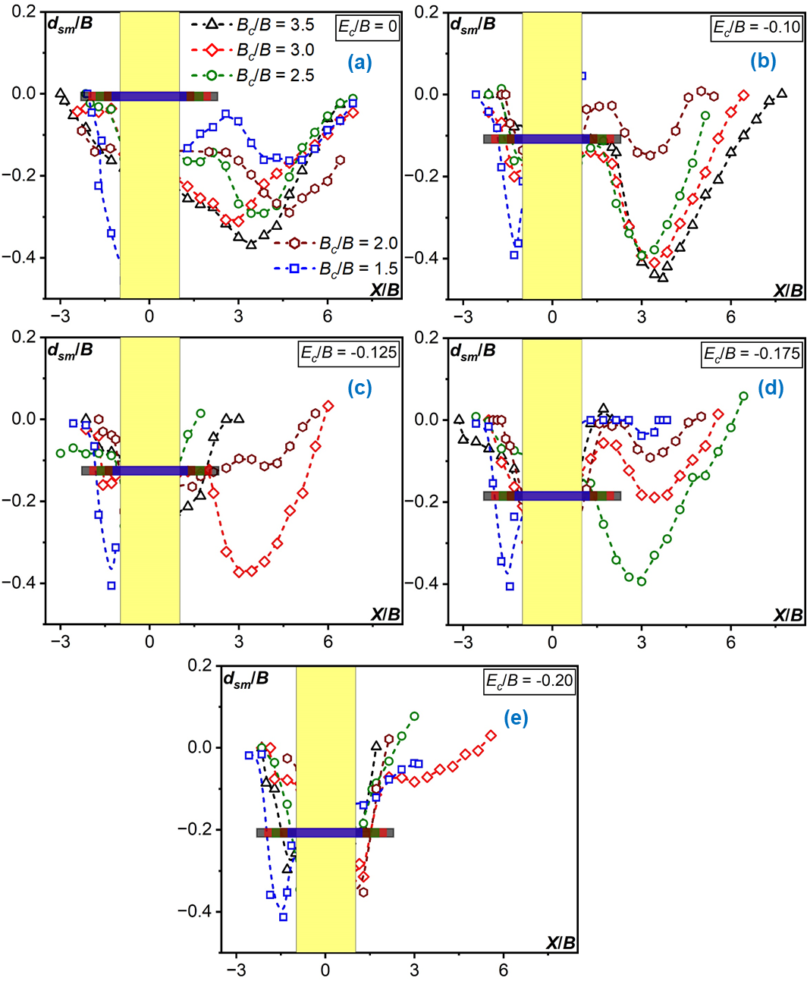
Fig. S1. Longitudinal profiles (X/B) of d_{sm}/B for different B_{c}/B: (a) E_{c}​/B = 0, (b) -0.10, (c) -0.125, (d) -0.175, and (e) -0.20. The yellow-shaded area represents the pier for L/B = 2.

